 Progressive Education Society's

Modern College of Engineering, Pune-05.

**DEPARTMENT OF ARTIFICIAL INTELLIGENCE & DATA SCIENCE**

**218559-Project Based Learning-II**

**Second Year [Semester-IV]**

**Academic Year-2021-2022**

**Project Synopsis**

1. **Team Members:**
2. Shankar Karande - 22571
3. Shreyash Walke - 22565
4. Ashutosh Kokate - 22537
5. Gayatri Korbad - 22540
6. Zakir Elaskar - 22521
7. **Tile of the Project**

Face Mask Detection Using Artificial Intelligence and IOT

1. **Problem Definition**

The novel coronavirus covid-19 had brought a new normal life. India is struggling to get out of this virus attack and the government implemented lockdown for the long way. Lockdown placed a pressure on the global economy. So, the government gave relaxations in lockdown. Declared by the WHO that a potential speech by maintaining distance and wearing a mask is necessary. The biggest support that the government needs after relaxation is social distancing and wearing of masks by the people. But many people are getting out without a face mask this may increase the spread of covid-19. Economic Times India has stated that " Survey Shows that 90 percent Indians are aware, but only 44 percent wearing a mask ". This survey clearly points that people are aware but they are not wearing the mask due to some discomfort in wearing and carelessness. This may result in the easy spreading of covid-19 in public places.

The world health organization has clearly stated that until vaccines are found the wearing of masks and social distancing are key tools to reduce spread of virus. So, it is important to make people wear masks in public places. In densely populated regions it is difficult to find the persons not wearing the face mask and warn them. Hence, we are using image processing techniques for identification of persons wearing and not wearing face masks. In real time images are collected from the camera and it is processed in Raspberry Pi embedded development kit. The real time images from the camera are compared with the trained dataset and detection of wearing or the world health organization has clearly stated that until vaccines are found the wearing of masks and social distancing are key tools to reduce spread of virus. So, it is important to make people wear masks in public places. In densely populated regions it is difficult to find the persons not wearing the face mask and warn them. Hence, we are using image processing techniques for identification of persons wearing and not wearing face masks. In real time images are collected from the camera and it is processed in Raspberry Pi embedded development kit. The real time images from the camera are compared with the trained dataset and detection of wearing or not wearing a mask is done. The trained dataset is made by using machine learning technique which is the deciding factor of the result. The algorithm created by means of using a trained dataset will find the persons with and without wearing face masks.

**Input Image**

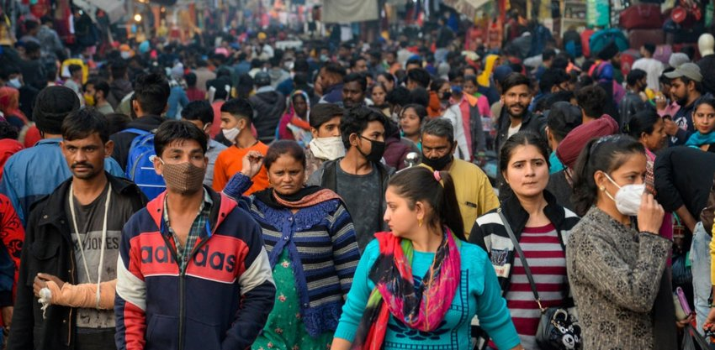

**Output Image**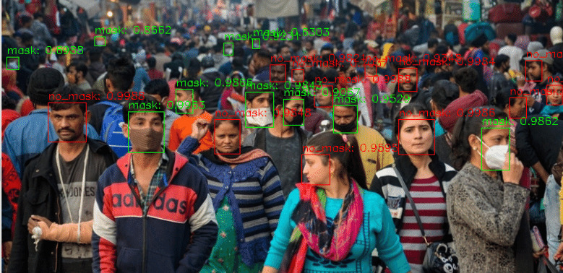

The Internet of Things (IOTs) can be used for connecting objects like smartphones, Internet TVs, laptops, computers, sensors and actuators to the Internet where the devices are linked together to enable new forms of communication between things and people, and between things themselves. Intimation messages are sent to authority persons by means of using IOT.

1. **Introduction**

The literature review is split into three main categories. In the first category, the literature related to image classification using deep learning techniques is discussed. In the second category, the Internet of Things (IOT) concepts are discussed. In the third category, the literature related to combined IOT devices and deep learning techniques are discussed.

1. **Hardware & Software Requirement**

* **Hardware Requirement**

.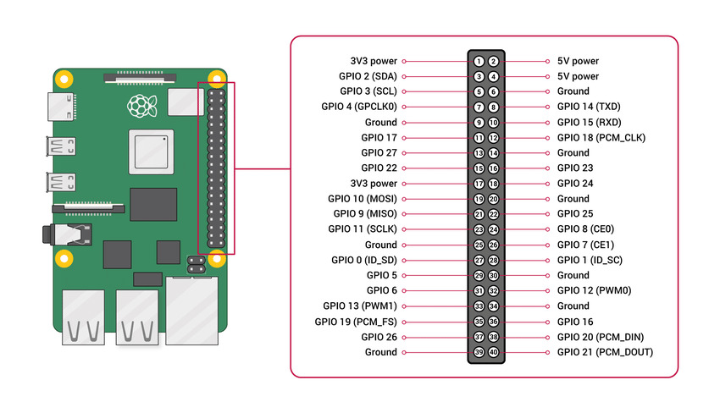 Figure 4.2: shows the Raspberry Pi 4 pin details.

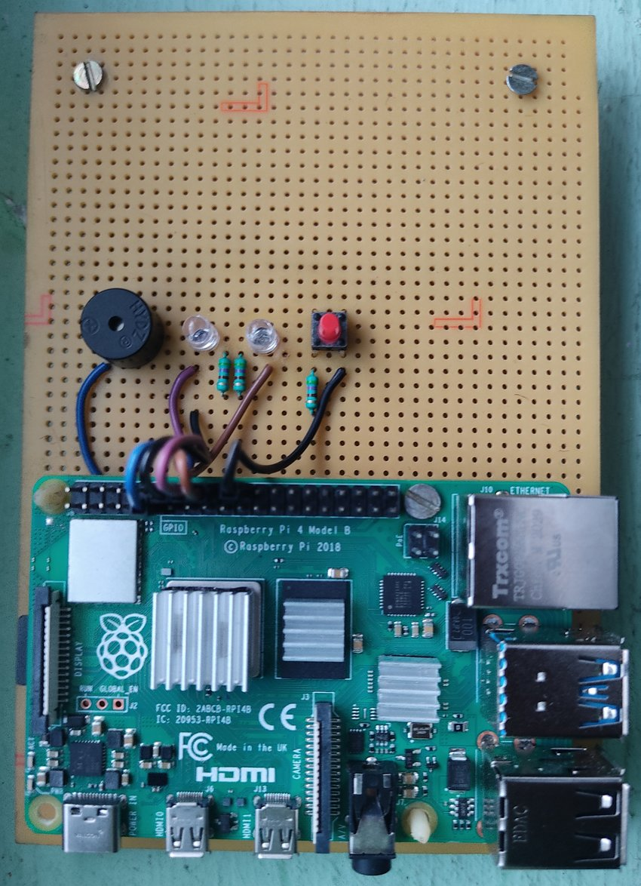

Raspberry Pi4 Development kit is used in this face mask detection system. The Raspberry Pi is a very cheap computer which runs on Linux OS, but it also provides a set of GPIO pins that are used to control electronic components and also Internet of Things. It is also used for image processing projects because of its processing speed and size. figure 4.1 shows the model setup of our project. Either camera or video stream is used as an input. The raspberry pi is connected with a buzzer and indication leads. For communication purposes we are using Blynk server (IOT) which is connected with the raspberry pi. figure 4.2 shows the Raspberry Pi 4 pin details.

* **Software Requirements**

**webIOPi**

There’s a lot of handy apps and tools out there, but since we want to make something ourselves, this time we’ll be using “WebIOPi” to operate GPIO with a browser. WebIOPi is a software used to materialize the “IoT (Internet of Things)” with Raspberry Pi. It looks like it was published on Google Code before. IOT (Internet of Things), the Internet of Things (IOT) is the network of physical objects—devices, vehicles, buildings and other items—embedded with electronics, software, sensors, and network connectivity that enables these objects to collect and exchange data. In WebIOPi’s case, input and output are performed with a browser. You can operate GPIO with a browser button, and likewise acquire values from GPIO and display them quite easily

**Weaved**

Weaved services connect you easily and securely to your Pi from a mobile app or browser window. Control remote computers using tcp hosts such as ssh (remote terminal) and VNC (Virtual Network Console). The easiest way we’ve seen to open up your Raspberry Pi as an Internet of Things device is to use the service Weaved. Weaved provides an IoT (Internet of Things) Kit for the Raspberry Pi. The kit provides really simple tools for connecting your Pi to the cloud, receiving notifications, and turning your Pi into an Internet of Things Kit.

**Jupyter Notebook**

The Jupyter Notebook is an open-source web application that allows you to create and share documents that contain live code, equations, visualizations, and narrative text. Its uses include data cleaning and transformation, numerical simulation, statistical modeling, data visualization, machine learning, and much more.

**Python Programming**

Python is a general-purpose interpreted, interactive, object-oriented, and high-level programming language. It was created by Guido van Rossum during 1985- 1990. Like Perl, Python source code is also available under the GNU General Public License (GPL). Python 3.0 was released in 2008. Although this version is supposed to be backward incompatible.

1. **Conclusion**

In this work of face mask detection, we have used YOLOv3 to detect the persons with face mask and without face mask with good efficiency and and sent an intimation message to authority persons by means of IOT. Its performance is really well in images and our detection results were also quite good. This detection can also be used for video stream or camera fed inputs. To get improved performance and speed, Raspberry Pi of higher variant such as 4GB or 8GB RAM can be used to implement the detection algorithm. The Future development of the project is planned to involve the identification of a person and sent the intimation message to the persons mobile who were not wearing face masks.

In this work of face mask detection, we have used YOLOv3 to detect the persons with face mask and without face mask with good efficiency and and sent an intimation message to authority persons by means of IOT. Its performance is really well in images and our detection results were also quite good. This detection can also be used for video stream or camera fed inputs. To get improved performance and speed, Raspberry Pi of higher variant such as 4GB or 8GB RAM can be used to implement the detection algorithm. The Future development of the project is planned to involve the identification of a person and sent the intimation message to the persons mobile who were not wearing face masks. This project will be very helpful and can be implemented in hospitals, airports, schools, colleges, offices, shops, malls, theaters, temples, apartments etc. and can also be implemented for Covid free event management.

1. **References/Bibliography**

* Ariyanto, Mochammad & Haryanto, Ismoyo & Setiawan, Joga & Muna, Munadi & Radityo, M. (2019). Real-Time Image Processing Method Using Raspberry Pi for a Car Model. 46-51.
* V. K. Bhanse and M. D. Jaybhaye, (2018) "Face Detection and Tracking Using Image Processing on Raspberry Pi," 2018 International Conference on Inventive Research in Computing Applications (ICIRCA), Coimbatore, India, pp. 1099-1103.
* A. Das, M. Wasif Ansari and R. Basak, (2020) "Covid-19 Face Mask Detection Using TensorFlow, Keras and OpenCV," 2020 IEEE 17th India Council International Conference (INDICON), New Delhi, India, pp. 1-5.
* Joseph Redmon, S. D. (2016) “You Only Look Once(YOLO) Unified, Real Time Object Detection” IEEE.